**Big Mountain Resort Project Report**

Based on the data provided and the model created with it, Big Mountain Resort should be able to comfortably increase it’s ticket prices. The resort is currently charging $81 for an adult weekend ticket, our model suggests that the market will support a ticket price of $95.87. This comes with a mean absolute error of $10.39, which means that there is certainly room for an increase in ticket price.

After initial examination of the data we chose to drop two columns and three rows due to missing data for the target variable. Adult weekend ticket price was chosen to be the target variable due to it having more complete data than adult weekday price.

As shown in the following scatter plot, there is no clear grouping by state regarding ticket price. With this taken into consideration, the region and state features were removed from analysis.

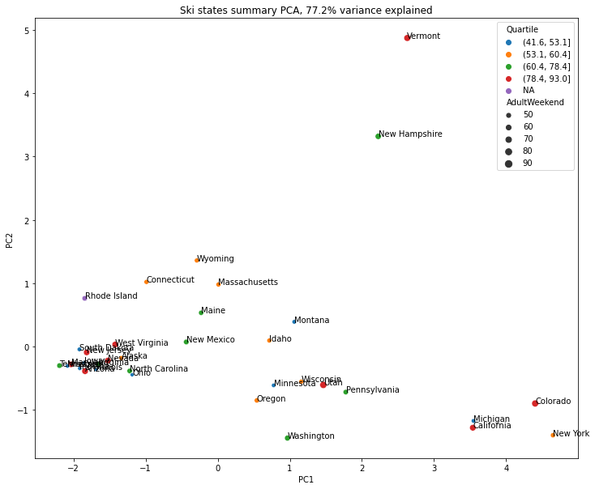

During pre-processing a number of different models were tested. The first was created using average ticket price, needless to say this model was not an effective predictor. Second we created a linear model. This model was tested twice, once population missing values using the median for the respective value, then again using mean. The model using median values returned better results. Both models were cross validated. The final model was a random forest model that yielded the best results and was chosen for final analysis.

As already stated, the model indicates that Big Mountain Resort should confidently be able to increase their ticket price. Some may hesitate to increase ticket prices due to Big Mountain already being the most expensive resort in Montana, but based on the resort’s exceptional facilities, an increase in price is justified.

There are a number of different ways revenue could be increased beyond simply increasing ticket price, the best of which would likely be closing down the resort’s least popular run. This will reduce operating costs for run maintenance while having no effect on how the market will value resort tickets.

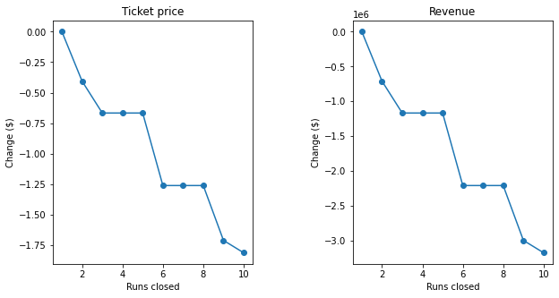

The limitations of this model come from a lack of operating cost data and the assumption that other resorts are basing their ticket prices off market demand. If more information was available for either of these two deficiencies the model could be significantly improved.